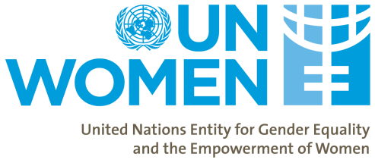

UN Women Civil Society Advisory Group for the Caribbean
candidates APPLICATION FORM
- Family Name: First Name:
- Nationality:
- Telephone: Fax:
- E-mail:

- Are you currently affiliated with an organisation? If yes, please explain the nature of the work you do within this organisation, how it is linked to gender equality and women’s empowerment issues in the Caribbean.

- What is your area of expertise, amongst the four priority areas for UN Women in the Region (Women’s Leadership and Political Participation; Women’s Economic Empowerment; Ending Violence against Women and Disaster Risk Reduction)?

- In the box below please provide a brief explanation of your suitability to be a member of UN Women Civil Society Advisory Group for the Caribbean.

Signed: Date:

